Hands-on 6: Standard Library & File Processing Architecture

1. Prerequisites
- Environment: Ensure your go.mod is initialized.
- Data File: You will need to create a sample data file (provided in Step 3).

2. Why are we doing this?
Most real-world Go applications act as "data processors." They read data (Files, APIs), transform it (Slices, Maps), and output it (JSON, XML). Understanding how Go handles Slices (dynamic arrays) and Maps (hash tables) is critical for performance, as Go allows you to handle millions of records with minimal memory overhead.

3. Objective
- Perform high-performance Slice manipulations (Filtering & Appending).
- Use Maps for O(1) complexity data lookups.
- Implement JSON Encoding/Decoding to simulate API data exchange.
- Mini-Project: Build a "Log Processor" that reads a text file, counts occurrences of errors, and exports a JSON summary.

4. Steps To Follow

Step 1: Advanced Collections (Slices & Maps)
Create collections.go. We aren't just storing data; we are filtering and mapping it.
package main
import (
"fmt"
"strings"
)
func main() {
// Slices: Dynamic and powerful
users := []string{"admin_root", "user_alice", "admin_backup", "user_bob"}
var admins []string
// Filtering pattern
for _, u := range users {
if strings.HasPrefix(u, "admin") {
admins = append(admins, u)
}
}
// Maps: Key-Value storage for fast lookups
userRoles := make(map[string]string)
for _, name := range users {
if strings.Contains(name, "admin") {
userRoles[name] = "SuperUser"
} else {
userRoles[name] = "General"
}
}
fmt.Printf("Filtered Admins: %v\n", admins)
fmt.Printf("Role Map: %v\n", userRoles)
}

Step 2: JSON Serialization & Time
Create data_formats.go. Go uses "Struct Tags" to map Go data to JSON keys.
package main
import (
"encoding/json"
"fmt"
"time"
)
type LogEntry struct {
Timestamp string `json:"time"`
Level string `json:"level"`
Message string `json:"msg"`
}
func main() {
// Creating data
entry := LogEntry{
Timestamp: time.Now().Format(time.RFC3339),
Level: "ERROR",
Message: "Database connection timeout",
}
// Marshal: Convert Struct to JSON (Byte slice)
jsonData, _ := json.MarshalIndent(entry, "", " ")
fmt.Println("Serialized JSON:\n", string(jsonData))
// Unmarshal: Convert JSON back to Struct
var decoded LogEntry
json.Unmarshal(jsonData, &decoded)
fmt.Printf("Decoded Message: %s (Logged at %s)\n", decoded.Message, decoded.Timestamp)
}

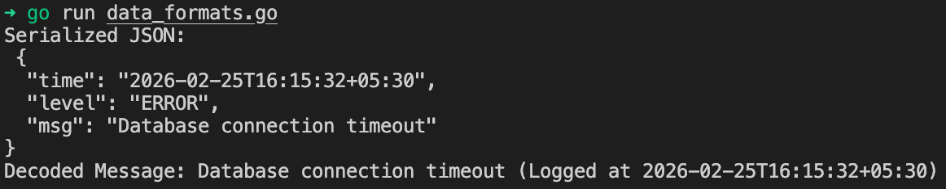

Step 3: Working with Files (The os Package)
Create a file named input.txt in your folder and add these lines:
INFO: System started
ERROR: Disk full
INFO: User logged in
ERROR: Unauthorized access

5. Mini-Project: The "Log Analytics Tool"
Create log_processor.go. This tool will read a file line-by-line (to save memory), count the error types using a Map, and output a JSON report.
package main
import (
"bufio"
"encoding/json"
"fmt"
"os"
"strings"
)
type AnalyticsReport struct {
TotalLines int `json:"total_lines"`
Counts map[string]int `json:"counts"`
Status string `json:"status"`
}
func main() {
filePath := "input.txt"
file, err := os.Open(filePath)
if err != nil {
fmt.Printf("Error opening file: %v\n", err)
return
}
defer file.Close()
counts := make(map[string]int)
totalLines := 0
// Use Scanner for memory-efficient line-by-line reading
scanner := bufio.NewScanner(file)
for scanner.Scan() {
line := scanner.Text()
totalLines++
// Extract log level (e.g., INFO, ERROR)
parts := strings.Split(line, ":")
if len(parts) > 0 {
level := parts[0]
counts[level]++
}
}
// Prepare final report
report := AnalyticsReport{
TotalLines: totalLines,
Counts: counts,
Status: "Processed Successfully",
}
// Save report to JSON file
outputFile, _ := os.Create("report.json")
defer outputFile.Close()
encoder := json.NewEncoder(outputFile)
encoder.SetIndent("", " ")
encoder.Encode(report)
fmt.Println("Analysis Complete. Summary:")
fmt.Printf("- Lines Processed: %d\n- Errors Found: %d\n", totalLines, counts["ERROR"])
fmt.Println("Full report saved to report.json")
}

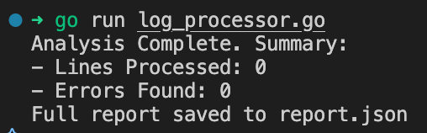

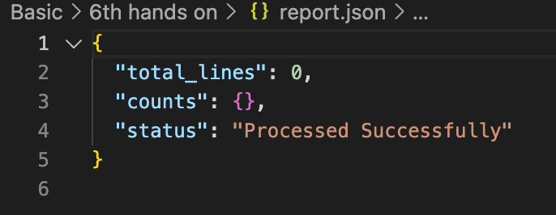

6. Checklist of Accomplishments
- [ ] Slice Filtering: Implemented the append pattern for dynamic data filtering.
- [ ] Map Aggregation: Used a map to count occurrences (frequency counter pattern).
- [ ] Struct Tags: Used `json:"key"` to control data output.
- [ ] File I/O: Used bufio.Scanner for efficient large-file reading (Streaming).
- [ ] Encoding: Generated a valid report.json using json.NewEncoder.

7. Conclusion
You have just built a production-style data pipeline. In Day 1, we learned how to store a single variable; now, you can process thousands of lines of data, categorize them using Maps, and export them in a format (JSON) that any modern web application can consume. You are effectively handling the "Storage and Transformation" layer of a backend system.

Congrats!
Check your directory—you should see report.json. Open it to see your results!

